# Projectplan

Författare: (Namn, Email)



# Project Overview

This section should contain the following information:

1. **Project assignment:** What the project is about, your customer, the main purpose of the product, what application does it have? Who are the intendent users of the product and how is the product supposed to be used? Use pictures/figures to provide an overview of your product.
2. **Selected development model:** Describe the model, explain why it was used and what you gain by using it or if something was not as good as you plan when following the model.
3. **Budget(Story points/hours), start recording hours/ story points from start:** 
   * + total budget, time and Effort available

|  |  |  |  |
| --- | --- | --- | --- |
| Activity | Planned hours/Effort | Actual hours/Effort | Comments |
|  |  |  |  |
|  |  |  |  |
|  |  |  |  |
|  |  |  |  |
|  |  |  |  |
|  |  |  |  |
|  |  |  |  |

1. **time line :**
   * + timeline (start and end date)
     + Milestone name/ a Milestone plan
     + Make sure to include information on:
       - major sub- deliveries to the customer, e.g Sprint Demo
       - final delivery date,
       - other important goals to reach

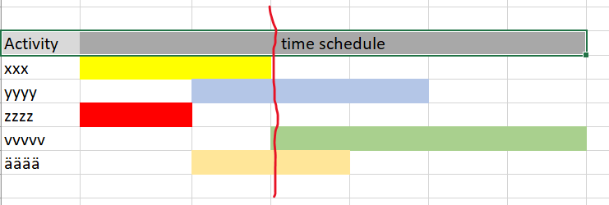

W 43

W 35

Date line of today

1. **Procedures and routines:** Define the procedures and routines that you used, this can include procedures for e.g. version control, risk management, code standard, measurements, technical meetings, time reporting etc.

# Requirements

In this section you shall fill in what requirements you have noticed and list them down in a structure so that it is possible to separate the different requirements in a good way e.g. as below, but you may use any structure like if you get a official structure to follow.

## Requiremments : Initial, Commited and Delivered

|  |  |  |  |
| --- | --- | --- | --- |
| Requirements | | | |
| Customer requirements | Requirements committed | Requirements delivered | Comments deviation |
| Functional requirements |  |  |  |
| RQ01…….. |  |  |  |
| …….. |  |  |  |
| ……… |  |  |  |
| ……… |  |  |  |
| Non-functional requirements |  |  |  |
| RQ01…….. |  |  |  |
| * Usability |  |  |  |
| RQu01……. |  |  |  |
| * Capacity |  |  |  |
| RQc01……. |  |  |  |
| * Accessibility |  |  |  |
| RQa01……. |  |  |  |
| * Maintainability |  |  |  |
| RQm01…….. |  |  |  |

If you are following an Agile way then it might be better for you to do a Product Backlog list where you list down the requirements still with the possibility to understand if it is a functional or non-functional requirement. And if I shall be able to see what you have Committed then you also need to bring in the Sprint Backlog list

The question that I see support the model above are:

1. What requirements did the customer have in total?
2. What requirements were committed (promised)?
3. What requirements were actually delivered ?

Hours or effort will be presented in your time sheet that you see under Budget and Time above

## Technical solution

1. Describe what technical solution will be used and what architecture you see is possible, why this is the best for the customer.
2. When at the project end describe changes or deviations just to the original plan
3. When at the end of the project make an analysis of the technical solution. What worked well? Any problems challenges, could you have done something different?

## Risk management

Attach a risk analysis that you will do at start already then use that as reference when answering :

1. Which of the identified risks happened and how well your risk management approaches worked?
2. Which risks did you miss? Why?
3. Which of the risks that you initially identified as serious risks actually did not and up being risk at all?

## Test

* 1. Describe what test approach will be used and why you think this is the best for your customer
  2. Make some test statistics (what was tested when and how?)